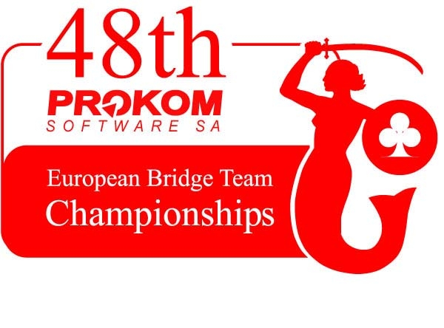



HOTEL RESERVATION FORM

For the participants of European Championship
12 – 26 August, 2006

InterContinental Warszawa
49 Emillii Plater
00-125 Warsaw, POLAND
tel. +48 22 328 88 88 / fax +48 22 328 88 89
e-mail: wrs_reservation@interconti.com

PLEASE RESERVE FOR ME (booking deadline 30 April 2006)

STANDARD ROOMS
- single occupancy EUR 100.00 - double occupancy EUR 120.00

The all above quoted are per room, per night. The rates include 7% VAT tax, buffet breakfast served in DownTown Restaurant and free used of RiverViewWellness Center as well as taxi transfer from and to the airport. Final bill will be issued in PLN applying National Bank of Poland exchanged rate valid on the arrival day.

Arrival Date | Time
Departure Date
Number of rooms
Name, Family Name
Company
Street / No
City / Postal Code
Country
Telephone | Fax
E-mail
Credit Card Type
Credit Card Number
Expiry Date
Smoking / Non smoking
Taxi transfer required / no required
Flight details

IMPORTANT NOTES

Room use is not guaranteed before 14.00 a.m. on the day of arrival. Every effort will be made to accommodate early arrivals. Rooms must be vacated no later than midday on the departure day (12.00 a.m.). If your arrival time is later than 4 p.m., please inform the hotel providing them with your full credit card number and its expiry date to secure your booking. All hotel payments should be made directly to the hotel. In case of NON SHOW the first night will be charged to your Credit Card. Deposit in cash or credit card for accommodation and breakfast and/or additional service depending on method of payment, will be collected at check-in.

Guest signature Date

___________________________ _______________________

